If this past year were a film it would be titled the Pesky Pandemic, featuring the star actor, Covid-19, and special guests—masks and sanitizer.

It has been a wild ride, this pandemic, with quarantine forcing employees to trade in their briefcases and desktops for Zoom calls and isolation.

Some of you may have enjoyed this adjustment to a work-from-home atmosphere, while others suffer the loss of in person connection with co-workers. For those who enjoy dressing to the nines for your on the clock endeavors, feeling motivated to dress yourself professionally for a waist up, virtual square meeting with your CEO might not be at the top of your to-do’s. But—square styling can be fun and affordable! Palmetto Goodwill offers a wide variety of trendy and sophisticated styles to keep you engaged and eager to dress up during these unprecedented times.

As seen straight from the runway, elevated basics present themselves to be comfortable and cost-effective, while still giving you the freedom to feel professional and cozy all in one!

Today I am going to take you through my favorite styled outfits from this week’s thrift—from the waist up of course!

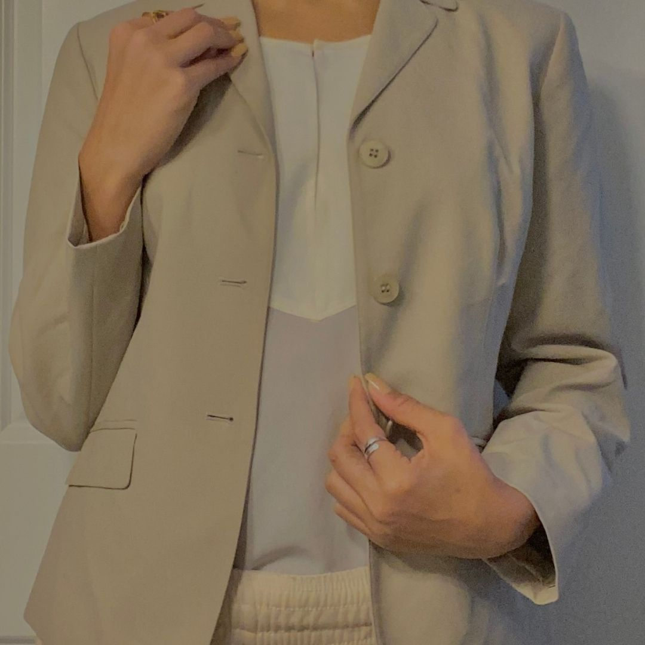

Look One:
A beige button-up blazer draped over a white satin tank. This perfect pair goes great together thanks to a rounded hem.. It is the ultimate duo for a Monday morning pow wow with your cohorts.

Look Two
This fitted camel button front dress has a casual charisma to it making it a quintessential standout piece for the pandemic era professional working wardrobe.

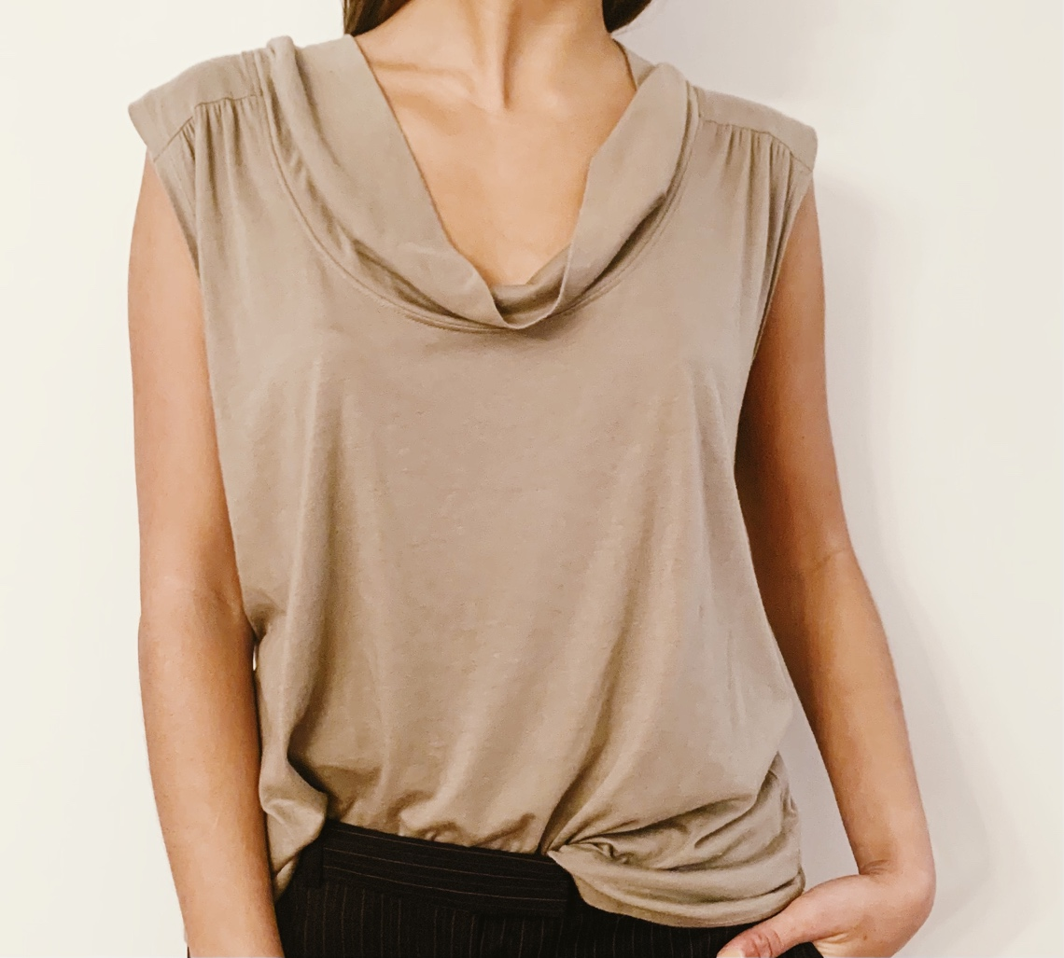
Look Three:
This olive tinted swoop-neck tank is a happy medium between a comfy cotton texture and cosmopolitan chic.

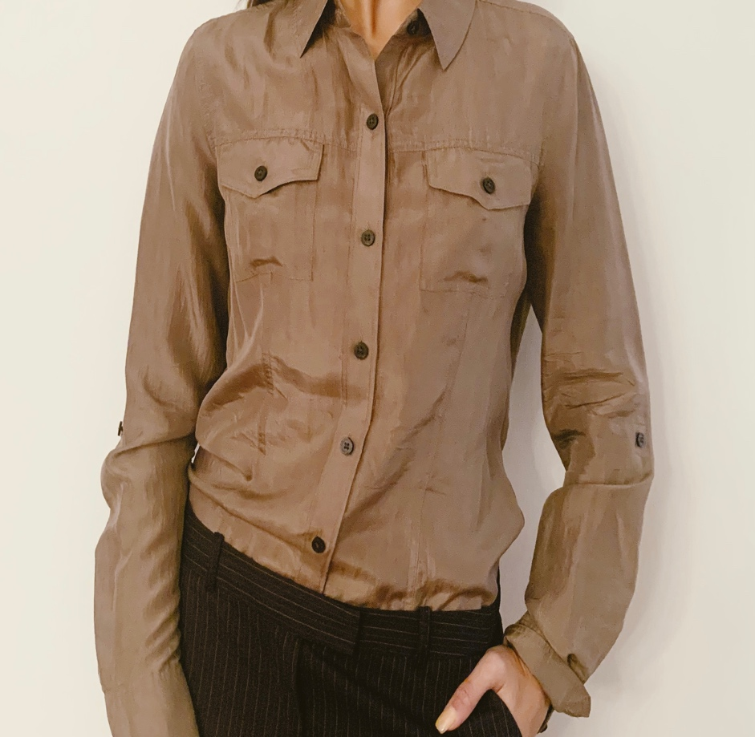

Look Four:
Gracing you with elegance and simplicity is this brown silk blouse. This shirt gives off a silky silhouette to perfect your ultimate virtual vision.

I highly encourage you to put on your favorite mask and take a quick trip to your local Goodwill and search for your own business basics!

Check out our Tik Tok to see how I styled the full outfits!

